**Guide to accessing UDON when off-campus for Windows.**

**Ensure that PULSE Secure is running by accessing**[**https://ntuanywhere.ntu.ac.uk/**](https://ntuanywhere.ntu.ac.uk/)

Once you have an active connection with PULSE Secure you can access the file structure by inputting \\udon in folder file path as shown in image below:

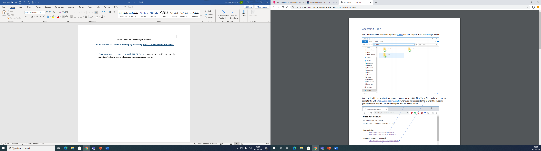

To access your own individual files, you need to click on web\ SOFT20171\ N012345 (Your username). You can move all the files you want on the server into this folder.

**Access to online files**

You can access your saved files from the server by accessing them from the URL; <https://udon.ads.ntu.ac.uk/> and then clicking on the link to SOFT20171.

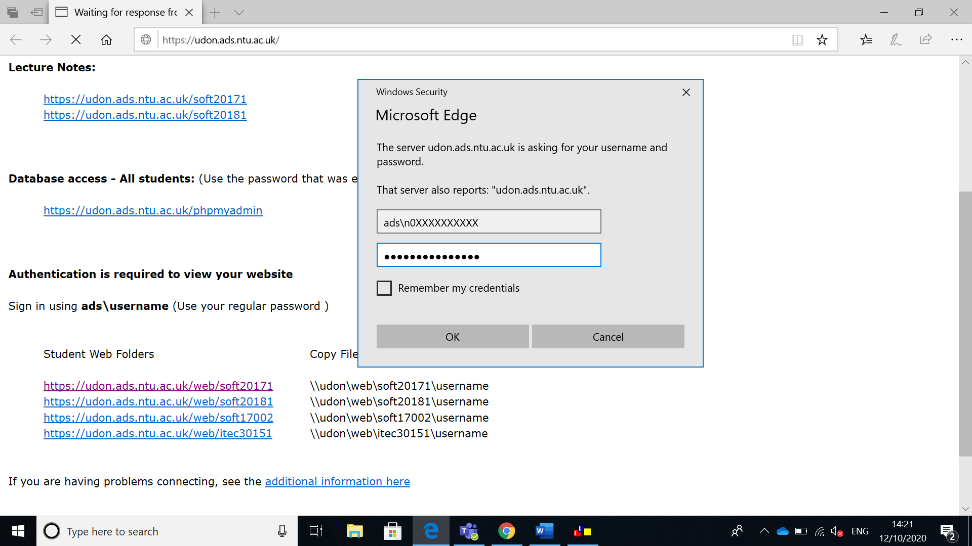

**NOTE:** You must make sure you have ‘ads\’ before your student ID.

For the above screen, to access the web folder you need to login using your NTU NOW login credentials. Once successfully logged in, you will see a list of folders, but you will only be able to access the folder that has your student ID displayed. You can then navigate to the file you want to see.

**Guide to accessing UDON when off-campus for Apple.**

For those of you with Apple Macs wanting to use the UDON server, follow these steps:

1. You need to have a working PULSE secure connection. To set this up, use: <https://support.ntu.ac.uk/hc/en-us/articles/201652036-NTUanywhere-Mac-OS-X-user-guide>
2. Go to Finder/ Go / Connect to Server
3. Type into server address: smb://udon/
4. Press connect
5. For the login: ensure you have clicked 'registered user'
6. For name and password, this should be your normal login to the university network.
7. Press connect
8. Several files should appear, you need to click on 'web'
9. The folder structure should appear. You need SOFT20171